New Hampshire Energy Efficiency

Calculation of Lost Base Revenue

For Measures installed beginning in 2019

Report Issued by the NH Lost Base Revenue (LBR) Working Group

Docket No. DE 17-136

August 29, 2018

Table of Contents

- Introduction
- Scope and Members of the LBR Working Group 2
- Executive Summary 3
C. Summary of LBR Calculations 3

- LBR Template and Glossary of Terms
- LBR Template 4
- Glossary of Terms Used in the LBR Template 6

- Derivation of kWh Savings
A. Gross kWh Savings 9
B. Net to Gross Percentage 10
C. In Service Rate 10
D. Realization Rate 10

E. Retirement Adjustment 10

- Derivation of kW Savings for Commercial and Industrial Customers
A. Connected Load Savings (kW) 10
B. Customer Peak Coincident Factor (CF) 11
C. Net to Gross Percentage 14
D. In-Service Rate 14
E. Realization Rate 15
F. Retirement Adjustment 15

- Derivation of Lost Base Revenue Average Distribution Rates (LBR ADR)
A. Description: How is LBR ADR Calculated 16
B. Distribution Rates and Billing Determinants Used in the LBR ADR 16
C. Summary of LBR ADR and Related Schedules 14

- Discussion of Ratchets 17

- Actual LBR Calculation 18

Appendices
A. 2019-2020 LBR Savings Calculation Templates 21
B. Planned kW and kWh savings for Lost Based Revenues 22
C. Example of Lighting Project Worksheet with kW Savings 25
D. Sample LBR ADR Calculations 28
D. Ratchet Analysis 28
F. Rate GV peak hours and DNV-GL peak load by end use 28
G. OCA Comments Including Resource Insight, Inc. Comments 28

I. Introduction

A. Scope and Members of the LBR Working Group

The scope of the Lost Base Revenue (LBR) Working Group’s activities is defined by Commission Order No. 26,095 in Docket DE 17‐136, which approved the Settlement Agreement. The Settlement Agreement adopts the method of calculating the average distribution rate for purposes of calculating LBR proposed by the Utilities (where the average distribution rate used in the calculation blends the kW and kWh rate components) for energy efficiency upgrades installed in 2017 and 2018. For upgrades installed in 2019 and thereafter, the method proposed by Staff will be used, whereby the average distribution rate is disaggregated into kW and kWh components. Per the Settlement Agreement, the LBR Working Group was established to determine the appropriate kW values to be used for the Commercial and Industrial sectors. Specifically, the LBR Working Group was established to consider the general impact of customer peak and the general impact of demand charge ratchets on those kW values. This Report represents a largely consensus document.

In the course of exploring the issues surrounding disaggregating LBR into kW and kWh components for commercial and industrial customers, the Working Group reviewed and produced many documents, some of which are posted to a page on the Commission website http://www.puc.state.nh.us/EESE%20Board/EERS_Working_Groups.html. These documents are posted for informational purposes only and the LBR Working Group members do not necessarily adopt or endorse the information and findings contained in these documents.
This Report is largely a consensus document produced by the Working Group members. However, while this Report was guided by and results from the Settlement Agreement (filed with the Commission on December 8, 2017 in DE 17-136), this Report is not intended as, and should not be construed as a Settlement Agreement. As such, Working Group members reserve the opportunity to take consistent or contrary positons when LBR is at issue in future proceedings before the Commission. The Report is a public document and may be used in future Commission proceedings. The Working Group meetings and related discussions that lead to the Report were not conducted as privileged or confidential sessions.
In addition, the Office of Consumer Advocate (OCA) recommends a significant reduction to the LBR results produced by the methods set out in this Report. The OCA’s recommendation and the Utilities’ Response to that recommendation are attached to the Report as Appendices G and H.

This Working Group Report, along with the Utilities and OCA comments will be posted to the Commission website.
The members of the LBR Working Group are:
- Jim Cunningham, NH PUC
- Paul Dexter, NH PUC
- Jay Dudley, NH PUC
- Elizabeth Nixon, NH PUC
- Leszek Stachow, NH PUC
- Brian Buckley, Office of Consumer Advocate
- Donald Kreis, Office of Consumer Advocate
- Rebecca Ohler, NH DES
- Tomas Fuller, Eversource
- Christopher Goulding, Eversource
- Miles Ingram, Eversource
- Marc Lemenager, Eversource
- Karen Asbury, Unitil
- Deborah Jarvis, Unitil
- Eric Stanley, Liberty
- Heather Tebbetts, Liberty

Staff wishes to take this opportunity to thank the members of the LBR Working Group who devoted many hours to meetings, research, information responses and preparation of slide presentations.

B. Executive Summary

The LBR Working Group met in order to establish the appropriate kW values to be used for the Commercial and Industrial sectors when calculating planned and actual LBR and to consider general impact of customer peak load and the general impact of demand charge ratchets on those kW values. The discussions of the LBR Working Group occurred over the six-month period January – June 2018 and the salient documents from these discussions are posted to the Commission website.

A major portion of the Working Group’s time was spent in developing a simplified one-page Template (ref. p. 6). The Template works as follows:

It begins with kWh savings authorized by the Commission (Template, Line 1-3)

Then, the template converts kWh savings to maximum kW load reduction based on a metric referred to as the maximum demand factor (MDF) (Template, Line 4)

The maximum load reduction is then reduced to load reduction at peak based on a metric referred to as coincident factor (CF). This is explained in the Report at Section IV, Figure 1. (Template, Line 5-6)

Then, kW load reduction at customer peak is adjusted for the following: (1) % Net to Gross, (2) % In-Service, (3) % kW Realization Rate, (4) % Billing Adjustment to Reflect Ratchets, (5) % Retirement Adjustment and (6) % Annual Savings Achieved in First Year (Template Line 8-19)
- Then, the remaining kW hours are multiplied by the lost base revenue average distribution rate (LBR ADR) to calculate LBR dollars (Template, line 20-21)

Staff supports the Template developed by the Working Group for the following reasons:

Template uses metrics that are transparent – e.g., uses kWh in the plan as a starting point; and measure lives that are in the Plan for determining retirement adjustments

Template is administratively expedient – e.g., highlights key information in a one-page template and avoids deriving data from computer models and spreadsheets.

Template makes limited use of certain, simplifying assumptions where appropriate – e.g., uses “half year convention” uniformly across all three utilities (for planning purposes, 50 percent of the annualized target kWh energy and kW demand savings for program year 2019 are assumed to be achieved in the first year (2019) and 100 percent are assumed to be achieved in subsequent years).

Template utilizes readily available information – e.g., template uses information contained in EM&V for savings assumptions; and, it uses Commission approved tariffs for calculating average distribution rates.

Staff notes that there are two items, in its view, that require additional review. One pertains to the ratchet adjustment and the other pertains to the OCA comments submitted by its consultant, Resource Insight. With respect to the ratchet adjustments, the Working Group did not produce a result that Staff can support at this stage of review. Staff believes that, based on Eversource’s presentations concerning ratchet, there appears to be little to no ratchet impact. However, Staff did not come to a similar conclusion concerning Unitil’s and Liberty’s ratchet analysis. Thus, Staff plans to continue its review of ratchet impacts for Unitil and Liberty as part of its review of the 2019 annual update filing.

With respect to comments and recommendations on the Report by OCA and the Utilities’ response, Staff envisions further discussion as part of discovery in the 2019 annual update filing review.

C. Summary of LBR Calculations

The LBR calculations for 2019 and 2020 by utility are disaggregated for kWh and kW, as agreed to in the Settlement Agreement. A template summarizing the calculation of LBR for planning purposes along with a glossary of terms is provided in section II. The derivation of key components of these calculations —kWh, kW, and Average Distribution Rates (ADR)—are described in sections III, IV and V. The impact of ratchets is discussed in section VI. The calculations result in the planned kW and kWh savings amounts for 2019 and 2020 (ref. Appendix B, Tables 1-3), using the customer peak kW approach detailed in section IV, and based on planned measure installations from the 2018 – 2020 New Hampshire Statewide Energy Efficiency Plan. Section VII describes actual reporting.

The Template in section II outlines the methodology used to calculate LBR, based on Eversource’s C&I Large Business Energy solutions Program, Retrofit Track, LED Lighting. In addition, the templates in Appendix A provide the 2019 and 2020 planned savings values and detailed calculations for kWh and customer peak kW savings for all programs.

Appendix B provides the planned MWh and kW savings used for the calculation of lost based revenue. Appendix B, Table 1 through 3, reflect savings based on planned measure installations. As in 2017-18, LBR collections for 2019-20 will be based on actual monthly measure installations, as detailed in this document. Appendix C provides an example of a Lighting Project Worksheet with kW savings. Appendix D provides details in support of the calculation of average distribution rates for LBR. Appendix E provides details related to ratchet analyses. Appendix F provides Eversource Analysis, Rate GV Peak Hour and DNV-GL operating percentages. Appendix G provides comments from OCA (including Resource Insight, Inc.); and Appendix H provides comments in response from the Utilities.

II. LBR Template and Glossary of Terms

A. LBR Template

This section provides the methodology that was developed by the LBR Working Group that Staff recommends be used to determine kW demand savings for purposes of calculating lost revenue, effective for the 2019 program year. It’s a summary of how Eversource will calculate kW savings for program year 2019, and is based on data contained in the 2018-2020 Plan – i.e., specifically, for the Large Business Energy Solutions Program, Retrofit Track LED Lighting measure. All other Eversource measures will be calculated using the same methodology. In addition, Unitil and Liberty will use the same methodology to determine kW savings for purposes of calculating LBR, effective for the 2019 program year. Details of the methodology are provided for Eversource, Unitil and Liberty in Appendix A; and match the methodology summarized in Table 1.

Table 1: Summary of LBR Methodology developed by the Working Group to be Used Starting in Program Year 2019

Line Description Value* Source

1 2019 Quantity 228 2018-2020 Plan (Bates 237)

2 2019 Gross Annual Savings per Unit (kWh) 63,006 2018-2020 Plan (Bates 237)

3 Maximum Demand Factor 0.0001814 2016 actual meas. Install.

4 Maximum Load Reduction kW 11.4 Line 2 x Line 3

5 Extended Maximum Load Reduction kW 2,600 Line 1 x Line 4

6 % kW Demand Reduction at Customer Peak 86.96% DNV-GL, Sept. 2015 data

7 Sub-Total, Customer Peak kW Reduction 2,261 Line 5 x Line 6

8 % Net to Gross Percentage 100% NH PUC Precedent

9 Sub-Total, Customer Peak kW Reduction 2,261 Line 7 x Line 8

10 % In-Service Rate 100% DNV-GL, Sept. 2015 Study

11 Sub-Total, Customer Peak kW Reduction 2,261 Line 9 x Line 10

12 % kW Realization Rate 0.977% DNV-GL, Sept. 2015 Study

13 Sub-Total, Customer Peak kW Reduction 2,209 Line 11 x Line 12

14 Billing Adjustment to Reflect Ratchets 100% LBR Report, Section VI

15 Sub-Total, Customer Peak kW Reduction 2,209 Line 13 x Line 14

16 Retirement Adjustment 100% LBR Report, Section III-F

17 Total Customer Peak Reduction, Full Year 2,209 Line 15 x Line 16

18 % of Annual Savings Achieved in first Year 50% Half-year convention

19 Total Customer Peak kW Reduction, First Year 1,105 Line 17 x Line 18

20 LBR ADR per kW $6.40 Appendix D

21 Lost Based Revenue (LBR) $7,072 Line 19 x Line 20

*Values are rounded

As noted above, the methodology laid out in this template is the methodology that will be used by Eversource, Unitil and Liberty, starting for program year 2019. For planning purposes 50 percent of the annualized target kWh energy and kW demand savings for program year 2019 are assumed to be achieved in the first year (2019) and 100 percent are assumed to be achieved in subsequent years.

B. Glossary of Terms Used in the LBR Template

Line 1, 2019 Quantity: The number of measures specified in the Plan; for Eversource (refer to the 2018-2020 Plan, Bates 237).

Line 2, 2019 Gross Annual Savings per Unit (kWh): The unit value of savings specified in the Plan (refer to the 2018-2020 Plan, Bates 237). For planning purposes, this unit value is assumed to be 100 percent of the realized value.

Line 3, Maximum Demand Factor (MDF): The ratio of the maximum demand (kW) during an assigned period to the energy (kWh) consumed during that period, usually expressed in a percent. For LBR planning purposes, MDF is calculated by dividing the maximum load reduction (kW) for a particular end use by the annual energy use (kWh) for that end use.

Line 4, Maximum Load Reduction: This value is the product of “2019 Gross Annual Savings per Unit” multiplied by the “Maximum Demand Factor “MDF)”.

Line 5, Extended Maximum Load Reduction kW: This value is the product of “Line 1, 2019 Quantity” multiplied by the “Line 2, Maximum Load Reduction”.

Line 6, % kW Demand Reduction Expected to Occur at Customer Peak: For planning purposes, the C&I Retrofit Lighting – LED demand reduction percentage in the Template reflects the C&I Program Impact Study conducted by DNV-GL (September , 2015 Study), as delineated by Eversource during the LBR Working Group meetings. The customer peak values reflect the Rate GV Class supply curves provided by Eversource during the Working Group meetings. See Section IV B for further explanation.

Line 7, Customer Peak kW Reduction: This value is the product of “Line 5, Extended Maximum Load Reduction kW” multiplied by the “Line 6, % kW Demand Reduction Expected to Occur at Customer Peak”.

Line 8, % Net to Gross: This value represents an adjustment to energy efficiency savings to reflect free-ridership and spillover. Due to the cost of EM&V studies, the Commission has preferred to spend limited funds on programs, rather than on studies to estimate adjustments for free-ridership and spillover. Thus, there is no impact for free-ridership and spillover incorporated in the Template.

Line 10, % In-Service Rate: The in-service rate only accounts for whether equipment is in place and functional. That is, the in-service rate is the percentage of measures, incented by an energy efficiency program, that EM&V studies estimate to be installed and capable of operating. The in-service rate is calculated by dividing the evaluation’s quantity of measures installed by the quantity of measures that are present in the utilities’ project files.

Line 12, % kW Realization Rate: The ratio of evaluated savings to claimed savings. Evaluated savings are savings identified by EM&V Studies. Clamed savings generally reflect project-specific calculations or deemed savings values, which are based on prior EM&V studies, engineering analyses, and equipment specifications.

Line 14, Billing Adjustment to Reflect Ratchets: A ratchet is a rate structure meant to increase revenue certainty from a particular set of customers that are more likely to have volatile consumption, with the intended outcome of lessening the potential burden on all other customers. For instance, according to Eversource, there are three optional levels of demand; and, the maximum level determines the billing demand (ref. Eversource Tariff, 5th revised page 67, section entitled Maximum Demand.) Paraphrasing this tariff, the ratchet demand is the third option and it is eighty percent (80%) of the amount by which the greatest amount defined in the two options during the eleven (11) preceding months exceeds 1,000 kilovolt-amperes is used for billing purposes. According to Eversource, this ratchet demand is rarely used for billing demand; and, Eversource considers it immaterial.

Line 16, Retirement Adjustment: This adjustment removes from the calculation kW associated with measures that have expired. The adjustment is expressed in terms of a percentage. The 100 percent in the Template indicates that 100 percent of the measures are still in service.

Line 18, Percent of annual Savings Achieved in First Year: This represents the half-year convention. In other words, for planning purposes, the annualized target kWh energy and kW demand savings for program year 2019 are assumed to be installed 50 percent in the first year (2019) and 100 percent in the second year (2020). Note, that for actual reporting purposes, actual savings will be incorporated in the final report for program year 2019.

Line 20, Lost Base Revenue Average Distribution Rate (LBR ADR) per kW: Effective for program year 2019, the average distribution rate is equal to the distribution revenue of a utility (e.g., revenues from kWh and/or kW rates) divided by consumption (e.g., kWh and/or kW consumption). The Utilities have excluded certain charges, such as the customer, meter, and luminaire charges, prior to performing this calculation to reach the ADR for LBR purposes. The utilities believe the appropriate term is the “LBR ADR”, as this modified rate is used solely for the purpose of calculating LBR.

III. Derivation of kWh Savings

The utilities will continue to use the same method for calculating kWh savings that has been used for prior years’ LBR reporting and collections. Although the method for kWh calculations is not within the scope of the LBR Working Group, the method is described below so that this document provides a complete accounting of LBR calculations and inputs.
The following kWh calculation is applied for each measure type within the utilities’ C&I and residential programs.

$LBR kWh Savings=Gross kWh Savings* Net to Gross Percentage* In Service Rate*Realization Rate- Retirement Adjustment$

The calculation is applied on a monthly basis, for the cumulative measures installed year-to-date. To account for the fact that measures are installed over the course of a month (not all on the first day of the month), the calculation claims savings beginning in the month of the paid date – which is on average two months after measures are installed and generating savings.. This helps to ensure the utilities avoid overstating LBR. For LBR forecasts, the utilities divide total annual planned kWh savings by 12 to determine the average monthly kWh savings. Each component of the calculation is described in detail in the following sub-sections.

Gross kWh Savings
The gross kWh savings for energy efficiency measures are determined on a project-specific basis at the time of project installation/implementation. The savings are currently determined by project engineers and implementation contractors based on equipment specifications and information on baseline conditions at the project site, or they are deemed for measures with consistent and well-documented savings values. For an example of project-specific kWh savings calculations, see Appendix C.

B. Net to Gross Percentage – See description in Section IV below.

C. In Service Rate – See description in Section IV below.

D. Realization Rate – See description in Section IV below.

E. Retirement Adjustment – See description in Section IV below.

IV. Derivation of kW Savings for Commercial and Industrial Customers

The calculations used to derive kW savings resulting from energy efficiency measures installed through the NHSaves programs are detailed below. The amount of kW savings resulting from any specific efficiency measure depends on how and when that measure is used. Therefore, kW savings vary significantly depending on the type of measure and the point in time for which savings are calculated.
The LBR calculations were developed to identify the kW savings resulting from different efficiency measures at the time of customers’ monthly peak demand—i.e., the demand used to determine customers’ monthly demand charges. The NH utilities’ demand charges and other components of their tariffs are available at https://www.puc.nh.gov/Regulatory/companies-regulated-tariffs.htm.
The following kW calculation is applied for each measure type within the utilities’ C&I programs, as only these customers are currently assessed demand (kW) rates and therefore see bill reductions when they experience kW savings.

$LBR kW Savings=Connected Load kW Savings*Customer Peak Coincident Factor* Net to Gross Percentage*In Service Rate*Realization Rate- Retirement Adjustment$

The calculation is applied on a monthly basis, for the cumulative measures installed year-to-date. To account for the fact that measures are installed throughout a month (not all on the first of the month), the calculation claims savings beginning in the month of the paid date—which is on average two months (approximately) after measures are installed and generating savings. This helps to ensure the utilities avoid overstating LBR. For LBR forecasts, the utilities use the annual planned kWh savings and apply a maximum demand factor (see section A below) to determine planned kW savings.
Each component of the calculation is described in detail in the following sub-sections, and a template with the calculations for the programs’ 2019 and 2020 planned installations is provided in Appendix A.

Connected load savings (kW)
The connected load savings for energy efficiency measures are determined on a project-specific basis at the time of project installation/implementation. The savings are currently determined by project engineers and implementation contractors based on equipment specifications and information on baseline conditions at the project site, or they are deemed for measures with consistent and well-documented savings values. For an example of project specific kW savings calculations, see Appendix A. In addition, the connected load savings for measures such as occupancy sensors or wi-fi thermostats reflect that their savings are driven by reduced run-time or reduced hours of use, rather than reductions in connected load. As a result, the connected load savings for such measures are typically very small.

Planning assumptions: The project specific kW savings calculations, such as those shown in Appendix C, are used to determine actual kW savings and lost revenues, but for forecasted kW savings, the utilities use several assumptions in the planning model to arrive at planned connected load savings for measures installed each year, by program and measure type (lighting, heating, cooling, etc.). These include:
- Measure quantities. Planned quantities for each measure type, based on prior years’ actual measures installed.
- Gross annual kWh savings per unit. Planned savings per unit, based on actual savings per unit from prior years’ installed measures.
- Maximum demand factor. Ratio of kW to kWh, based on the ratio of kW to kWh savings for prior years’ projects
- Maximum load reduction kW. Equal to the product of gross annual kWh savings per unit and the maximum demand factor.
- % of Annual Savings Achieved in First Year. The utilities apply a 50% factor to reflect an average installation date of halfway through the year. On average, measures installed in 2019 will achieve half of their full annual savings in 2019, and 100% of their annual savings in subsequent years until their retirement.
These assumptions and values are included in the template in Appendix A.

Customer peak coincident factor (CF)
The kW demand reduction at customer peak is derived by multiplying the connected load kW savings by a factor representing the coincidence of usage (i.e., “percent on”) for each measure type at the peak hour for average C&I customers in Eversource’s service territory for each month of the year. Eversource NH Rate GV customers were chosen for determining average C&I customers’ peak hour, because they are a large, varied group of C&I customers over a similar geographic range as other utilities’ customers, and recent data were available on their hourly usage for each month.
Figure 1 below illustrates this concept, by combining (1) usage data for Eversource NH Rate GV customers and (2) end use load shape data from the most recent impact evaluation of the New Hampshire C&I program, completed by DNV-GL in September 2015, to identify the coincidence factor (CF) for a specific end use—in this case interior LED lighting—at the average customer’s peak hour in July. The figure shows an average Rate GV customer peak of 2:00 PM in July, at which time 81.9% of interior LED lighting is in use.

Figure 1: Eversource NH Customer Load and Interior Lighting Coincidence Factor (CF) 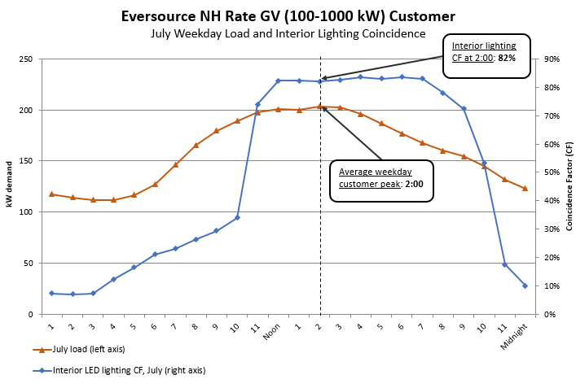
Source: Eversource NH average hourly kW demand by month and day-type, based on all Rate GV customers’ usage from September 2015 – August 2016. Downloaded from https://www.eversource.com/content/nh/about/about-us/doing-business-with-us/energy-supplier-information/electric---new-Hampshire. Indoor LED lighting coincidence from DNV-GL, as gathered and analyzed for the 2015 evaluation, Large C&I Retrofit and New Equipment & Construction Impact Evaluation, Sep 25, 2015. See NH PUC website at http://www.puc.state.nh.us/Electric/Monitoring%20and%20Evaluation%20Reports/New%20Hampshire%20Large%20C&I%20Program%20Impact%20Study%20Final%20Report.pdf
This approach was chosen for calculating customer peak demand impacts—including the use of DNV-GL load shape data—because it is the most accurate methodology and data currently available for determining the impacts of energy efficiency measures on customer demand charges. DNV-GL gathered load shape data via site visits to 68 sites with projects installed in 2012 through the New Hampshire utilities’ large C&I programs. Each site visit consisted of a verification of installed equipment and collection and analysis of monitored or trended data. Monitoring was performed for an average of seven weeks. Spot power monitoring was performed as needed to assess the efficiency of the unit of interest. When possible, energy management system data was used to obtain additional information and operating schedules. All of the monitoring equipment which was used to determine demand reduction and coincidence complies with the requirements of the ISO-New England Manual for Measurement and Verification of Demand Resources (M-MVDR). In addition, Eversource Rate GV customer usage profiles were used to determine customers’ peak hour, because they are a representative group of C&I customers, with recently collected hourly demand data.
For several measure types—refrigeration, domestic hot water, and motors/drives—DNV-GL did not gather end use load shape data as part of the 2015 evaluation. To determine customers’ peak demand impacts for these measure types, load shape data from the Electric Power Research Institute (EPRI) was used. This data was chosen because it is the best available source for these end uses where DNV-GL load shapes are not available, and it was the approach and the data source recommended in the January 23, 2018 memorandum from Optimal Energy to NHPUC staff. The EPRI load shape data are a web accessible database of best-available U.S. end-use load data for each customer sector (e.g., commercial and industrial) in each region of the country (e.g., Northeast). According to EPRI, the data are drawn from multiple sources, including EPRI’s field pilots, regional utility studies (e.g., BPA’s Pacific Northwest Residential Building Stock Assessment) or through historical collaborative activities such as the EPRI CEED (Center for End-Use Energy Data) PowerShape™ data of 2000-01. As stated on the EPRI website, “the objective of the Load Shape Library is to facilitate the collection, use and functionality of a library of representative electric load shapes by climate zone, geography or by utility. Representative load shapes are a challenge to acquire due to the cost to collect end use level load data. While EPRI and the utility membership work towards acquiring national and regional statistically representative load data, EPRI Program 170 A (End-Use Energy Efficiency and Demand Response Analytics) has developed an analytical framework with a web accessible database of best-available U.S. load data.” Based on Optimal’s recommendation, as well as working group review of the data, these data are the most suitable set of end use load shape data available for determining customer peak kW impacts of those energy efficiency measures for which DNV-GL load shapes are not available.
In applying these data to customer’s monthly load shapes, several assumptions were made. First, EPRI’s load shape data are available for peak (summer) and off-peak (winter) seasons. The calculations take the conservative approach of applying peak values to June, July, and August—the months of ISO-NE summer peak period—and off-peak values to all other months. Second, the data are available for average and peak weekdays. The peak weekday values were applied, to reflect those days when customer’s individual monthly peaks were more likely to occur.
Table 2 below shows the average customer peak hour for Eversource Rate GV customers for each month, the CF values for that month based on the DNV-GL data, where available, the EPRI data for each end use where DNV-GL data were not available, and the annual average CF. The template in appendix B illustrates how these values are applied to the LBR calculations.

Table 2: C&I Weekday Peak Hour End Use Coincident Factors (CFs)

AVERAGE CUSTOMER PEAK HOUR COINCIDENCE FACTORS, WEEKDAY
 |  | DNV-GL load shapes |  |  |  |  |  |  |  |  |  |  | EPRI load shapes |  |  |  |  | Custom (average all measures)
Month | Peak Hour | Lighting | Occ Sens |  | LED | Process |  | Cooling |  | Park Lot Lights |  | Heating | Refrig | Water Heating |  | Machine/ Drives
January | 11.0 | 0.75 | 0.67 |  | 0.87 | 0.63 |  | 0.03 |  | 0.00 |  | 0.69 | 0.76 | 0.98 |  | 0.99 |  | 0.63
February | 11.0 | 0.75 | 0.67 |  | 0.83 | 0.64 |  | 0.01 |  | 0.00 |  | 0.69 | 0.76 | 0.98 |  | 0.99 |  | 0.62
March | 11.0 | 0.75 | 0.67 |  | 0.83 | 0.64 |  | 0.11 |  | 0.00 |  | 0.70 | 0.76 | 0.98 |  | 0.99 |  | 0.63
April | 12.0 | 0.75 | 0.67 |  | 0.92 | 0.76 |  | 0.19 |  | 0.00 |  | 0.69 | 0.77 | 1.00 |  | 0.99 |  | 0.67
May | 14.0 | 0.75 | 0.66 |  | 0.87 | 0.80 |  | 0.30 |  | 0.00 |  | 0.71 | 0.77 | 0.99 |  | 1.00 |  | 0.68
June | 14.0 | 0.75 | 0.66 |  | 0.86 | 0.81 |  | 0.63 |  | 0.00 |  | 0.00 | 1.00 | 0.57 |  | 1.00 |  | 0.62
July | 14.0 | 0.76 | 0.54 |  | 0.87 | 0.80 |  | 0.80 |  | 0.00 |  | 0.00 | 1.00 | 0.57 |  | 1.00 |  | 0.62
August | 14.0 | 0.75 | 0.65 |  | 0.88 | 0.80 |  | 0.64 |  | 0.00 |  | 0.00 | 1.00 | 0.57 |  | 1.00 |  | 0.62
September | 14.0 | 0.74 | 0.69 |  | 0.88 | 0.81 |  | 0.56 |  | 0.00 |  | 0.00 | 0.77 | 0.99 |  | 1.00 |  | 0.63
October | 14.0 | 0.75 | 0.67 |  | 0.88 | 0.73 |  | 0.17 |  | 0.00 |  | 0.73 | 0.77 | 0.99 |  | 1.00 |  | 0.66
November | 12.0 | 0.75 | 0.67 |  | 0.92 | 0.66 |  | 0.16 |  | 0.00 |  | 0.71 | 0.77 | 1.00 |  | 0.99 |  | 0.65
December | 11.0 | 0.73 | 0.67 |  | 0.83 | 0.63 |  | 0.09 |  | 0.00 |  | 0.70 | 0.76 | 0.98 |  | 0.99 |  | 0.63
12-Month Average |  | 0.75 |  | 0.66 | 0.87 |  | 0.73 |  | 0.31 |  | 0.00 | 0.47 | 0.82 |  | 0.88 |  | 1.00 | 0.64

C. Net to Gross Percentage
This percentage is assumed to be 100%, per the New Hampshire Energy Efficiency Working Group Report, 1999. As stated in the report, “although Group members agree that program designs should attempt to minimize free-riders, the Group concluded that the methodological challenges and associated costs of accurately assessing free-riders no longer justifies the effort required to net these out of cost-effectiveness analyses.” The report also allowed inclusion of spillover, but to date the utilities have not measured spillover or included it in cost-effectiveness analyses. The utilities have made numerous efforts to design programs to minimize free-ridership by requiring customer investment of time and resources, such as through conservative, judicious use of up-stream and mid-stream offerings.

D. In-Service Rate
This rate reflects the percentage of measures, incented by an energy efficiency program, that EM&V studies estimate to be installed and capable of operating. Per program design, and consistent with other jurisdictions, C&I projects are inspected post-installation, and incentives are provided based on successful installation. Therefore, installation rates for C&I programs are 100%.

E. Realization Rate
This rate reflects the ratio of evaluated savings measured in impact evaluations to claimed savings based on utilities’ savings algorithms. Realization rates reflect various impact factors measured in evaluations, including in-service rates, coincidence factors, and hours of operation. Therefore, applying realization rates and other impact factors from the same study may result in double-counting these impacts.
As shown in the template in Appendix A, the calculations apply realization rates for each measure type from the best available, most recent impact evaluation of the New Hampshire C&I program, completed by DNV-GL in September 2015. Because these realization rates already account for the impact of in-service rates, realization rates did not add in-service rates a second time in order to avoid double counting..

F. Retirement Adjustment
The kW savings will be adjusted by subtracting savings for measures that reach the end of their measure lives, using the same mechanism the utilities currently use as required by ISO-NE for forward capacity market reporting. Bates 237 and 238 of the Utilities Three year Plan provides a schedule of measure lifetimes for Eversource’s C&I programs. As shown, the shortest measure life in these programs is a 9-year measure life for Retrofit Occupancy Sensors, meaning retirement adjustments for these measures installed in 2019 would not occur until 2028. Per Settlement Agreement DE 15-137, “retirement adjustments will be made to savings achieved due to expired measures, and shall apply to measures installed on or after January 1, 2017. Savings associated with an expired measure will be removed from the lost revenues calculation on the ending date of the measure's estimated useful life. Adjustments to savings from evaluation, monitoring, and verification ("EM&V") studies shall be included in the calculation of lost revenues for measures installed in the following program year.” As such, if a measure’s life is altered via an EM&V study, all measures installed in the subsequent calendar year will have the new measure life applied, while all measures installed up to that point will have the old measure life applied.

V. Derivation of Average Distribution Rates (ADR)

A. Description: How is LBR ADR calculated

The LBR ADR is equal to the distribution revenue of a utility (e.g., revenues from kWh and kW rates) divided by consumption (e.g., kWh and kW consumption). For lost base revenue calculated with savings from measures installed in 2018, kWh and kW revenue will be combined and divided by kWh to calculate a single ADR for each sector. For lost base revenue calculated based on savings for measures installed in 2019 and 2020, there will be separate kWh and kW LBR ADR Rates for each sector, where applicable. Note that the LBR ADR rates differ from utility to utility.

B. Distribution Rates and Billing Determinants used in the ADR calculation (i.e.: vintage)
Generally, distribution rates in effect at the time of the forecasted LBR plan shall be used for creating the LBR forecast. The forecast will also include the most recent calendar year of billing determinants. Upon reconciliation of LBR and calculating the actual LBR to be recovered, billing determinants and rates in effect during the calendar year covered shall be used. Thus, 2017 billing determinants and rates will be used for calculating actual 2017 LBR. The lost revenue calculation for 2017 will use 2017 EE savings (the first year lost revenue is assessed) and 2017 rates and tariffs. The 2018 lost revenue calculation will use 2017+2018 EE savings and 2018 rates and tariffs, if different, as all of these savings would have been billed under 2018 rates and tariffs. Future years will continue to be calculated in a similar manner, less any retired measures’ savings.
C. Summary of LBR and ADR schedules (attached in Appendices A and D).
Appendix A illustrates the estimated savings to be achieved for program years 2019 and 2020, and how they are calculated.
The calculation of LBR ADR is provided by utility in Appendix D for illustration. As indicated above, generally, distribution rates in effect at the time of the forecasted LBR plan shall be used for creating the LBR forecast as well as the most recent calendar year of billing determinants.
As shown, the LBR ADR rates are calculated by sector by taking the sector’s distribution revenue divided by the sector’s usage. For lost base revenue calculated with savings for measures installed in 2017 and 2018, kWh and kW revenue are combined and divided by kWh to calculate a single ADR for each sector. For lost base revenue calculated based on savings for measures installed in 2019 and 2020, there are separate kWh and kW ADR rates for each sector.
When actual LBR is calculated, the relevant period for both rates and billing determinants will be used. For example, 2017 LBR ADR will use 2017 billing determinants and 2017 distribution rates.

VI. Discussion of Ratchets

The working group was tasked with considering the general impact of demand charge ratchets. A description of each utility’s ratchet provision and discussion of impact to kW savings from energy efficiency measures is provided below.

Eversource: For Eversource, only LG customers are potentially impacted by a ratchet. Please refer to page 67 of Eversource’s Tariff No. 9 for how demand is billed for these customers. Eversource’s analysis of customers billed under its ratchet concluded that ratchets had a 0% impact from energy efficiency measures. No ratchet adjustment is necessary.

Unitil: For Unitil, only its G1 class (customers with average use equal or in excess of 200 kVA and generally greater than or equal to 100,000 kWh each month) includes a ratchet provision. G1 customers are billed the highest of a) current month's peak 15 min. kVA or b) 80% of previous 11 month's peak 15 min. kVA. The data provided in Appendix D shows the effect of the ratchet on kVA billed to G1 customers who participated in energy efficiency in 2017.

As shown, ratcheted kVa for these customers is 5% higher than the metered kVa. Note that sector demand savings also include the G2 class which does not have a demand ratchet. However, this does not necessarily mean that installed energy efficiency demand savings were 5% lower due to the ratchet. For instance, a customer could be billed on a ratchet in the early part of the year and then complete an energy efficiency project in the middle of the year. The impact of the ratchet is still included in the percentage calculation although the ratchet and energy efficiency project have no relation to each other. In a second example, suppose a customer completes an energy efficiency project early in the year, but then later in the year, is billed on a ratchet due to a high summer peak caused by weather. The summer peak was still lower by the amount of the installed energy efficiency project thus the Company still lost revenue even though the ratchet was implicated. Even in instances where a ratchet may be billed for an entire year, an energy efficiency project would have had an impact on what that ratcheted demand was ‐‐ if not during the current year, then in the following year, since the ratchet only looks back 11 months. As agreed to in the settlement establishing this working group, it is not feasible to identify the impacts with precision and not feasible to track demand charge impacts on a customer by customer basis. Overall, the ratchet only comes into play for 4 months on average, and is very small in percentage terms, thus Unitil determined that no ratchet adjustment to demand savings is necessary.

Liberty: For Liberty, its G-1 and G-2 rate classes include a monthly ratchet. The Company is in the process of reviewing whether or not it is appropriate for the G-2 rate class (customers with monthly usage of 20 kW to 200 kW) to include the ratchet and will be addressing the ratchet in its next rate case, to be filed in 2019. The calculation of the ratchet is provided in Granite State Electric’s Tariff No. 20 on page 98 for Rate G-1 and page 101 for Rate G-2. Liberty reviewed the Rate G-1 customers billed on a ratchet in 2017 who also received energy efficiency funds for projects. The review showed there were 11 out of 92 customers billed on a ratchet who received energy efficiency funds. The results showed that 3 of the 11 did not incur a ratchet after the energy efficiency was installed. Liberty determined that the analysis was inconclusive because 3 of the 8 customers who received energy efficiency savings and incurred a ratchet after the installations, had a ratchet that was less than the demand savings, thus the measures installed may have actually reduced the ratchet the customer could have incurred without the measures being installed .

VII. Actual LBR Calculation

The utilities track the number of measures actually installed, starting in the month of the paid date for each measure. Beginning on January 1, 2019 the utilities will use the calculations described in Sections III and IV above to derive the associated lifetime and monthly kWh and kW savings for installed measures. This data will be tracked monthly, in the same manner as kWh has been tracked for LBR in 2017 and 2018. In the utilities’ update filing made the following June (e.g. calendar year 2019 LBR will be filed in June 2020), the Actual LBR will be calculated and filed with the Commission. Legacy savings from measures installed in 2017 and 2018 will continue to have their LBR calculated in a manner consistent with the settlements approved in DE 15-137 and DE 14-216. More specifically, all 2017 and 2018 measures that have not yet been retired will have 100% of their kWh savings multiplied by an LBR ADR rate that combines the total demand and kWh charges into a single LBR ADR per sector. In addition, 100% of the program year’s monthly installed kWh and kW Savings will be tallied, and the resulting savings will be subject to the adjustments laid out within sections III and IV of this document. The savings will then each be multiplied by their respective sector LBR ADR (defined above with illustrative calculations included in Appendix D) which will be updated each year to reflect the rates in effect during the year in which the LBR is being collected. The sum of the calculations will then be taken to reach the Total Actual LBR, which represents the total dollars that would have been collected absent the installed energy efficiency measures. For further clarification, the 2019 and 2020 Actual LBR Calculations will be as follows:

2019
$$\left(2017+2018 Legacy Residential LBR kWh Savings*2019 Residential ADR\right)$$
$$+ \left(2017+2018 Legacy C\&I LBR kWh Savings*2019 C\&I [kWh+kW] ADR\right)$$
$$+ \left(2019 Installed Residential LBR kWh Savings*2019 Residential ADR\right)$$
$$+ \left(2019 Installed C\&I LBR kWh Savings*2019 C\&I kWh ADR\right)$$
$$+ \left(2019 Installed C\&I LBR kW Savings*2019 C\&I kW ADR\right)$$
$=2019 Total Actual LBR$

2020
$$\left(2017+2018 Legacy Residential LBR kWh Savings*2020 Residential ADR\right)$$
$$+ \left(2017+2018 Legacy C\&I LBR kWh Savings*2020 C\&I [kWh+kW] ADR\right)$$
$$+ \left(2019 Legacy Residential LBR kWh Savings*2020 Residential ADR\right)$$
$$+ \left(2019 Legacy C\&I LBR kWh Savings*2020 C\&I kWh ADR\right)$$
$$+ \left(2019 Legacy C\&I LBR kW Savings*2020 C\&I kW ADR\right)$$
$$+ \left(2020 Installed Residential LBR kWh Savings*2020 Residential ADR\right)$$
$$+ \left(2020 Installed C\&I LBR kWh Savings*2020 C\&I kWh ADR\right)$$
$$+ \left(2020 Installed C\&I LBR kW Savings*2020 C\&I kW ADR\right)$$
$=2020 Total Actual LBR$

Appendix

Appendix A: 2019-2020 LBR savings calculation templates (attached)

Appendix B: Planned kW and kWh savings for Lost Based Revenue (attached)

Appendix C: Example of Lighting Project Worksheet with kW Savings (attached)

Appendix D: Sample LBR ADR calculations (attached)

Appendix E: Ratchet Support Analyses (attached)

Appendix F: Eversource Analysis, Rate GV Peak Hour and DNV-GL operating %’s (attached)

Appendix G: OCA Comments, Including Resource Insights, Inc. Comments (attached)

Appendix H: Utility Comments

Appendix A: 2019-2020 LBR savings calculation templates

Appendix B (1 of 3): Planned kW and kWh savings for Lost Based Revenue

Table 1: Eversource Planned Savings for Lost Base Revenues, Measures Installed in 2019 and 2020
Program | 2019 MWh Savingsª | 2020 MWh Savingsª | 2019 kW Savings^{b} | 2020 kW Savings^{b}
Savings from Measures Installed in 2019
Large C&I Retrofit | 12,701.22 | 25,402.44 | 1,695.70 | 3,391.40
Large C&I New Equipment and Construction | 9,491.54 | 18,983.08 | 760.69 | 1,521.38
Large C&I Energy Rewards RFP | 2,102.71 | 4,205.42 | 349.01 | 698.02
Small C&I Retrofit | 4,407.44 | 8,814.87 | 740.72 | 1,481.44
Small C&I New Equipment and Construction | 1,336.86 | 2,673.71 | 244.38 | 488.75
Small C&I Direct Install | 1,752.73 | 3,505.45 | 437.63 | 875.27
Municipal | 1,799.74 | 3,599.47 | 138.86 | 277.73
Sub-total C&I and Municipal | 33,592.22 | 67,184.44 | 4,367.00 | 8,733.99
ESHomes | 485.755 | 971.51 | n/a | n/a
ESProducts | 3,995.64 | 7,991.28 | n/a | n/a
HEA | 411.92 | 823.84 | n/a | n/a
HPwES | 289.185 | 578.37 | n/a | n/a
Home Energy Reports | 2,966.80 | 5,933.60 | n/a | n/a
Sub-total Residential | 8,149.30 | 16,298.60 | n/a | n/a
Total, 2019 Measures | 41,741.52 | 83,483.04 | 4,367.00 | 8,733.99
Savings from Measures Installed in 2020
Large C&I Retrofit | n/a | 16,415.94 | n/a | 2,191.64
Large C&I New Equipment and Construction | n/a | 12,254.73 | n/a | 982.15
Large C&I Energy Rewards RFP | n/a | 2,974.28 | n/a | 493.67
Small C&I Retrofit | n/a | 5,761.04 | n/a | 968.21
Small C&I New Equipment and Construction | n/a | 1,747.43 | n/a | 338.81
Small C&I Direct Install | n/a | 2,291.02 | n/a | 572.04
Municipal | n/a | 1,633.52 | n/a | 126.04
Sub-total C&I and Municipal | n/a | 43,077.94 | n/a | 5,672.56
ESHomes | n/a | 682.94 | n/a | n/a
ESProducts | n/a | 3,460.76 | n/a | n/a
HEA | n/a | 551.32 | n/a | n/a
HPwES | n/a | 418.93 | n/a | n/a
Home Energy Reports | n/a | 5,950.40 | n/a | n/a
Sub-total Residential | n/a | 11,064.35 | n/a | n/a
Total, 2020 Measures | n/a | 54,142.28 | n/a | 5,672.56
ªSee annual MWh savings sub-totals for C&I and Residential on Bates 222 and 227. First year savings are divided in half.
^{b}The kW savings values reflect monthly demand charge impacts. Annualized kW savings are derived by multiplying by 12.
Appendix B (2 of 3): Planned kW and kWh savings for Lost Based Revenue
Table 2: Liberty Planned Savings for Lost Base Revenues, Measures Installed in 2019 and 2020
Program | 2019 MWh Savingsª | 2020 MWh Savingsª | 2019 kW Savings^{b} | 2020 kW Savings^{b}
Savings from Measures Installed in 2019
Large C&I Retrofit | 1,307.57 | 2,615.14 | 203.90 | 407.79
Large C&I New Equipment and Construction | 793.18 | 1,586.37 | 69.26 | 138.53
Small C&I Retrofit | 980.35 | 1,960.70 | 123.55 | 247.09
Small C&I New Equipment and Construction | 421.97 | 843.94 | 71.76 | 143.52
Municipal | 151.25 | 302.50 | 9.23 | 18.47
Sub-total C&I and Municipal | 3,654.32 | 7,308.63 | 477.70 | 955.40
ESHomes | 47.2 | 94.4 | n/a | n/a
ESProducts | 502.40 | 1,004.80 | n/a | n/a
HEA | 39.9 | 79.8 | n/a | n/a
HPwES | 27.65 | 55.3 | n/a | n/a
Home Energy Reports | 270.00 | 540.00 | n/a | n/a
Sub-total Residential | 887.15 | 1,774.30 | n/a | n/a
Total, 2019 Measures | 4,541.47 | 9,082.93 | 477.70 | 955.40
Savings from Measures Installed in 2020
Large C&I Retrofit | n/a | 1,735.60 | n/a | 270.58
Large C&I New Equipment and Construction | n/a | 1,066.87 | n/a | 94.13
Small C&I Retrofit | n/a | 1,281.23 | n/a | 159.75
Small C&I New Equipment and Construction | n/a | 617.31 | n/a | 105.70
Municipal | n/a | 151.60 | n/a | 306.79
Sub-total C&I and Municipal | n/a | 4,852.61 | n/a | 936.96
ESHomes | n/a | 78.9 | n/a | n/a
ESProducts | n/a | 635.00 | n/a | n/a
HEA | n/a | 52.2 | n/a | n/a
HPwES | n/a | 36.95 | n/a | n/a
Home Energy Reports | n/a | 180.00 | n/a | n/a
Sub-total Residential | n/a | 983.05 | n/a | n/a
Total, 2020 Measures | n/a | 5,835.66 | n/a | 936.96
ªSee annual MWh savings sub-totals for C&I and Residential on Bates 260 and 265. First year savings are divided in half.
^{b}The kW savings values reflect monthly demand charge impacts. Annualized savings are derived by multiplying by 12.

Appendix B (3 of 3): Planned kW and kWh savings for Lost Based Revenue
Table 3: Unitil Planned Savings for Lost Base Revenues, Measures Installed in 2019 and 2020
Program | 2019 MWh Savingsª | 2020 MWh Savingsª | 2019 kW Savings^{b} | 2020 kW Savings^{b}
Savings from Measures Installed in 2019
Large C&I Retrofit | 1,484.36 | 2,968.72 | 179.26 | 358.53
Large C&I New Equipment and Construction | 589.75 | 1,179.50 | 100.03 | 200.05
Large C&I Energy Rewards RFP | - | - | - | -
Small C&I Retrofit | 297.48 | 594.96 | 49.15 | 98.31
Small C&I New Equipment and Construction | - | - | - | -
Small C&I Direct Install | 909.39 | 1,818.78 | 112.01 | 224.02
Municipal | 229.29 | 458.57 | 16.45 | 32.91
Sub-total C&I and Municipal | 3,510.26 | 7,020.53 | 456.91 | 913.82
ESHomes | 32.55 | 65.09 | n/a | n/a
ESProducts | 920.34 | 1,840.67 | n/a | n/a
HEA | 35.24 | 70.47 | n/a | n/a
HPwES | 38.62 | 77.25 | n/a | n/a
Home Energy Reports | 506.49 | 1,012.99 | n/a | n/a
Sub-total Residential | 1,533.24 | 3,066.47 | n/a | n/a
Total, 2019 Measures | 5,043.50 | 10,087.00 | 456.91 | 913.82
Savings from Measures Installed in 2020
Large C&I Retrofit | n/a | 2,232.39 | n/a | 258.29
Large C&I New Equipment and Construction | n/a | 832.15 | n/a | 142.57
Large C&I Energy Rewards RFP | n/a | - | n/a | -
Small C&I Retrofit | n/a | 463.93 | n/a | 75.84
Small C&I New Equipment and Construction | n/a | - | n/a | -
Small C&I Direct Install | n/a | 1,303.32 | n/a | 155.67
Municipal | n/a | 214.83 | n/a | 15.78
Sub-total C&I and Municipal | n/a | 5,046.62 | n/a | 648.16
ESHomes | n/a | 40.62 | n/a | n/a
ESProducts | n/a | 1,107.91 | n/a | n/a
HEA | n/a | 43.09 | n/a | n/a
HPwES | n/a | 45.48 | n/a | n/a
Home Energy Reports | n/a | 345.78 | n/a | n/a
Sub-total Residential | n/a | 1,582.88 | n/a | n/a
Total, 2020 Measures | n/a | 6,629.50 | n/a | 648.16
ªSee annual MWh savings sub-totals for C&I and Residential on Bates 319 and 324. First year savings are divided in half.
^{b}The kW savings values reflect monthly demand charge impacts. Annualized kW savings are derived by multiplying by 12.

Appendix C: Example of Lighting Project Worksheet with kW Savings
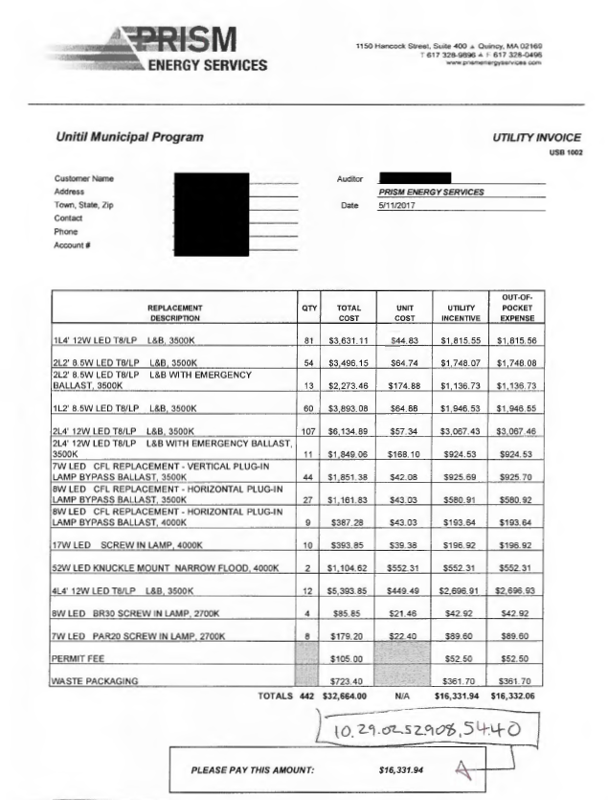
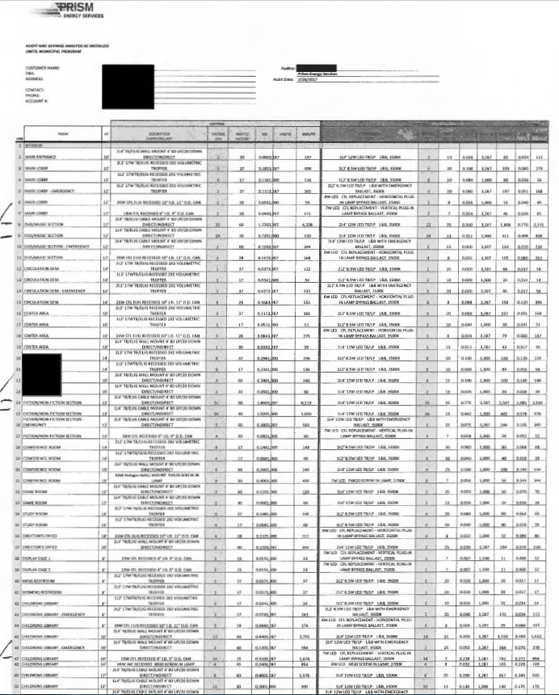
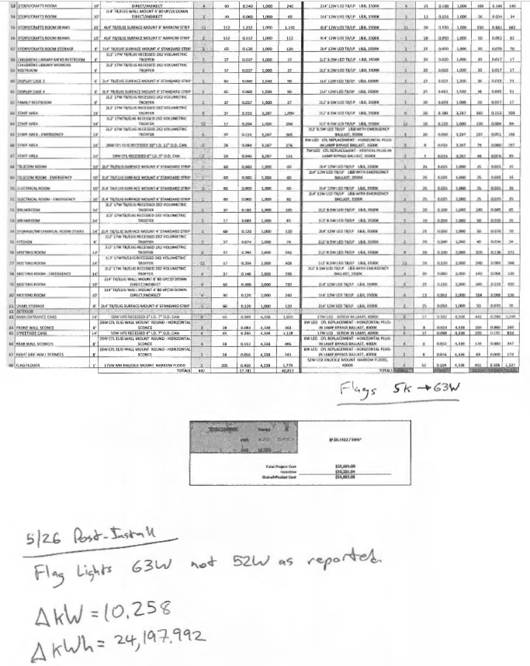

Appendix D: Sample LBR ADR calculations

Appendix E: Ratchet Support Analyses

Appendix F: Eversource Analysis, Rate GV Peak Hour and DNV-GL operating %’s

Link to Eversource Rate GV Peak Hour
https://www.eversource.com/content/nh/about/about-us/doing-business-with-us/energy-supplier-information/electric---new-Hampshire.
Link to DNV-GL Report, September 2015
http://www.puc.state.nh.us/Electric/Monitoring%20and%20Evaluation%20Reports/New%20Hampshire%20Large%20C&I%20Program%20Impact%20Study%20Final%20Report.pdf

Appendix G: Link to OCA and Resource Insight, Inc. Comments

Appendix H: Utility Comments

Savings values in Tables 1 – 3 are based on planned measure quantities and savings from the 2018-2020 Plan. Planned measure quantities and savings will be updated in the 2019 and 2020 plan updates.
Source: Commission Website, Core Programs, Monitoring & Evaluation Reports.
Source: Eversource analysis of Rate GV peak hours and DNV-GL peak load by end use (ref. Appendix F).
Source: Eversource Supply Curves showing peak demand for Rate GV customers. (ref. Appendix F).
According to “NEEP, Glossary of Terms”, a free-rider is a program participant who would have implemented the program measure or practice in the absence of the program. Free riders can be: 1) total, in which the participant’s activity would have completely replicated the program measure; 2) partial, in which the participant’s activity would have partially replicated the program measure; or 3) deferred, in which the participant’s activity would have completely replicated the program measure, but at a future time than the program’s timeframe. According to NEEP’s Glossary of Terms, Spillover is the reductions in energy consumption and/or demand caused by the presence of an energy efficiency program, beyond the program-related gross savings of the participants and without financial or technical assistance from the program. There can be participant and/or non-participant spillover. Participant spillover is the additional energy savings that occur when a program participant independently installs energy efficiency measures or applies energy saving practices after having participated in the efficiency program as a result of the program’s influence. Non-participant spillover refers to energy savings that occur when a program nonparticipant installs energy efficiency measures or applies energy savings practices as a result as a result of a program’s influence.
Source: DNV-GL Study, September 2015, p. 68.
According to NEEP, The term is used in several contexts in the development of reported program savings. The primary applications include the ratio of project tracking system savings data (e.g. initial estimates of project savings) to savings: 1) adjusted for data errors, 2) that incorporate evaluated or verified results of the tracked savings, and 3) that account for free ridership and/or spillover.
According to Eversource analysis, the ratchet option was immaterial. In the sensitivity analysis, the percentage of total demand billing that represented ratchet demand billing was 0.4%. For customers with a ratchet that potentially could have implemented EE or other non-EE changes at facility or temperature sensitive load changes, the maximum possible impact from EE on Eversource’s billing demand from ratchets for this time frame would be 0.002%. http://www.puc.state.nh.us/EESE%20Board/EERS_WG/061318_wg_eversource_ratchet_analysis.pdf According to the Unitil’s analysis, Unitil concluded that the impact of the ratchet was small in percentage terms and, as agreed to in the settlement establishing this working group, it is not feasible to identify the impacts with precision and not feasible to track demand charge impacts on a customer by customer basis. http://www.puc.state.nh.us/EESE%20Board/EERS_WG/061318_unitil_ratchet_analysis.pdf According to Liberty’s analysis, the ratchet option is inconclusive – 3 out of 8 who received EE savings and incurred a ratchet after the installation; but, the ratchet was less than the demand savings; thus, the measures installed may have actually reduced the ratchet the customer could have incurred without the measures being installed (Ref.LBR Report at section VI)
Per Order No. 26,095 approving the Settlement Agreement, the LBR Working Group was established to determine the kW values to be used in LBR calculations in the C&I sector, not kWh values
For example, in 2017, Eversource’s small business projects were installed 67 days prior to their paid date, on average, and Eversource’s large business projects were inspected 59 days prior to their paid date, on average.
For example, in 2017, Eversource’s small business projects were installed 67 days prior to their paid date, on average, and Eversource’s large business projects were inspected 59 days prior to their paid date, on average.
MDF values are derived for each measure type within each program. Eversource’s MDF values are derived by dividing the sum of the maximum demand (kW) savings for the prior year’s installations of the given measure type and program, by the sum of the annual kWh savings for those installations. For instance, 2016 Large C&I New Construction cooling measures had total annual kWh savings of 443,563 kWh, and total maximum demand savings of 270.1 kW. The MDF used for planning for 2017 Large C&I New Construction cooling measures is 270.1 / 443,563 = .000608933. This ratio is used for planning purposes to determine the expected total maximum demand savings for a given measure type and program, based on the planned annual kWh savings for that measure type and program. For Unitil and Liberty, MDF values are based on longer-term historical data on kW and kWh of various end uses. This is because they have a relatively small number of projects each year, which means the kW and kWh values for one prior year may vary more significantly and are therefore not as reliable for planning forecasts. Also see https://www.puc.nh.gov/EESE%20Board/EERS_WG/3_15_2018_worksheet_in_utilities_lbr_homework.xls.
The utilities conducted sensitivity analysis using load profiles for Eversource C&I customers under Rate G and Rate LG, and found insignificant differences in peak hours and resulting customer peak coincidence factors. See “Rate Class Comparison” worksheet within the Eversource template in appendix A.
DNV-GL, Large C&I Retrofit and New Equipment & Construction Impact Evaluation, Sep 25, 2015. http://www.puc.state.nh.us/Electric/Monitoring%20and%20Evaluation%20Reports/New%20Hampshire%20Large%20C&I%20Program%20Impact%20Study%20Final%20Report.pdf.
For more information on data collection and analysis methods, see DNV-GL, Large C&I Retrofit and New Equipment & Construction Impact Evaluation, Sep 25, 2015, at http://www.puc.state.nh.us/Electric/Monitoring%20and%20Evaluation%20Reports/New%20Hampshire%20Large%20C&I%20Program%20Impact%20Study%20Final%20Report.pdf
See https://www.puc.nh.gov/EESE%20Board/EERS_WG/013118_optimal_oca_lbr_wg_memo.pdf. For EPRI end use load shape data, see http://loadshape.epri.com/enduse. The utilities used the peak weekday load shapes for commercial customers in the Northeast Power Coordinating Council region.
See https://www.puc.nh.gov/Electric/96-150%20%20NH%20Energy%20Efficiency%20Working%20Group%20Final%20Report%20(1999).pdf
DNV-GL, Large C&I Retrofit and New Equipment & Construction Impact Evaluation, Sep 25, 2015. http://www.puc.state.nh.us/Electric/Monitoring%20and%20Evaluation%20Reports/New%20Hampshire%20Large%20C&I%20Program%20Impact%20Study%20Final%20Report.pdf, p.68, table 34.
Staff Comment: With respect to retirement adjustments (section II, Table 1, line 16), the utilities currently retire all measures based on the measure life determined at the time of installation, and those estimates continue for the duration of the measure life. Staff recommends that, as EM&V studies are conducted and reveal changes to the measure life of these installations, LBR calculations, going forward, should reflect these changes – i.e., LBR calculations going forward should reflect updated measure life for these measures installed in prior years and future years. Currently, the utilities are reflecting updated measure life only for measures installed in future years. Staff recommends this adjustment be considered for the next triennium (2021-2023). See “Introductory Comments” describing the Report as largely a consensus document.
Staff Comment: With respect to LBR ADR, the utilities currently use an overall average by C&I Rate class (ref. Report at Section V and Appendix D). For improved accuracy, Staff recommends that the utilities use discrete average distribution rates by rate class beginning no later than in the next triennium (2021-2023). See “Introductory Comments” describing the Report as largely a consensus document.
Staff Comment: With respect to ratchets and LBR, Staff believes it would be an improvement if the utilities could develop a uniform methodology for determining the ratchet impact for planning purposes (ref. LBR Template, line 14). For instance, Eversource analyzed the customer rate class that was billed under the ratchet (Rate GV) and determined the total KVA demand for this rate class – i.e., 2,703,760 KVA. Then, it determined the KVA ratchet impact for customers who had energy efficiency measures installed, or 3 KVA. By dividing the KVA ratchet impact by the total KVA demand for the customer rate class, Eversource determined the ratio was immaterial – i.e., 0.00001, or 0.001 percent. Also, Eversource analysis included data that would allow for other metrics as well (ref. Report at Section VI and Appendix E). Staff believes it is important for Unitil and Liberty to devise a similar sensitivity analysis, perhaps the same analysis since that would provide for uniformity in the consideration of ratchet impacts. Given the varied analyses presented and the inconclusive conclusions on impacts, Staff plans to continue its review of the methodology for determining ratchet impacts in the context of Staff’s review of the utilities’ 2019 program year filing.
Currently, the utilities do not assess demand charges within their Residential rate classes.

